
Above is how I want you to arrange the scroll such that it will be scrolling 4 messages per time.
I changed the css file you gave me and I got this.
I want you to expand yours to accommodate big content as above.

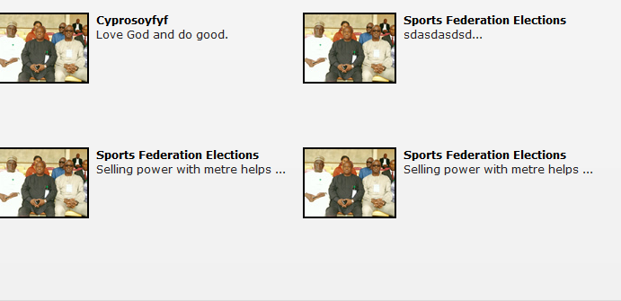

I added many information and I got displayed on the others as below
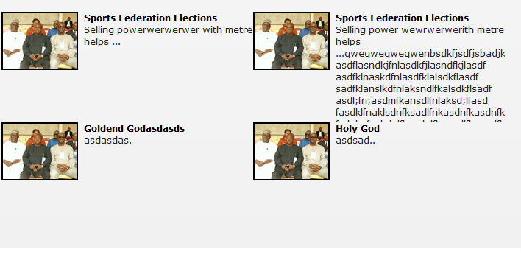

Maybe you do the entire file since I have have adjusted the file trying to get it but it refused.

